Anthony Le

ST 511

10/18/2016

Homework 3

Exercise 27:

1. (i) 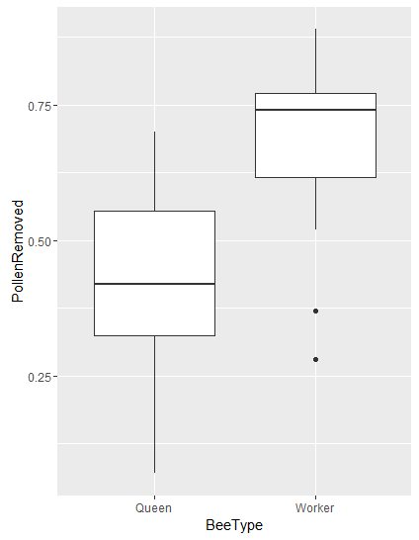

(ii) 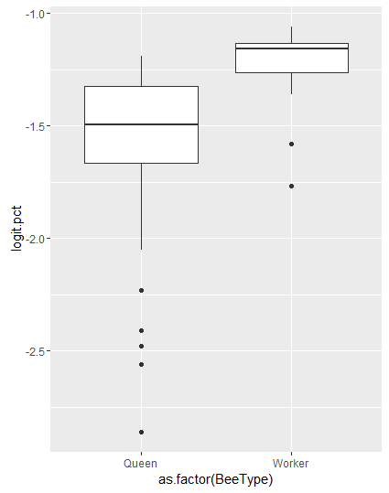

(iii) H0: µ1-µ2=0; H1: µ1-µ2<0;

Data: logit.PollenRemoved by BeeType

|  |  |  |  |  |  |
| --- | --- | --- | --- | --- | --- |
| Two-Sample T-Test | | | | | |
|  | t | p-value | df | 95% Confidence  Interval | Means |
| One-Sided | -2.679 | 0.005137 | 45 | -Inf, -0.129 | Queen: -1.596  Worker: -1.253 |
| Two-Sided | -2.679 | 0.01027 | 45 | -0.605, -0.0858 | Queen: -1.596  Worker: -1.253 |

There is convincing evidence that the mean difference in the proportion pollen removed between queens and workers is nonzero (one-sided p-value=0.005137 for a two-sample t-test). It is estimated that the mean is 0.0835 less pollen removed by the queens compared to workers. A 95% confidence interval for the difference is from 0.546 to 0.918.

Exercise 33:

1. H0: µ1-µ2=0; H1: µ1-µ2>0;

Data: log.BrainSize by LitterSize

|  |  |  |  |  |  |
| --- | --- | --- | --- | --- | --- |
| Two-Sample T-Test | | | | | |
|  | t | p-value | df | 95% Confidence  Interval | Means |
| One-Sided | 1.975 | 0.0256 | 94 | 0.0631, Inf | Large: 7.0247  Small: 4.723 |
| Two-Sided | 1.975 | 0.0512 | 94 | -0.00211, 0.796 | Large: 7.0247  Small: 4.723 |

There is strong evidence that the mean brain size of large litters is greater than that of small litters (one-sided p-value=0.0256, from a two-sample t-test). The mean brain size of large litters was estimated to be 2.302 greater than the mean brain size of small litters. A 95% confidence interval for the difference in brain size means is 0.998 to 2.217 (1000 x (Brain weight/Body weight)). Therefore, causation can be inferred between the litter size and brain size.

Question 3:

1. 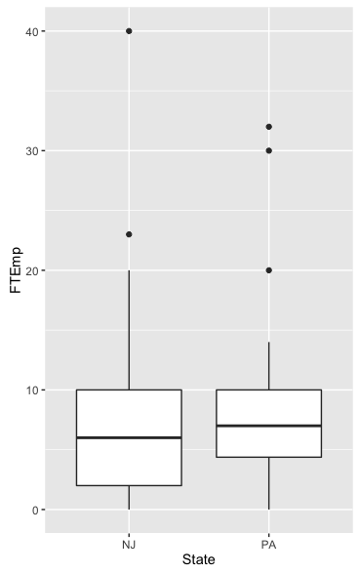
2. H0: µ1-µ2=0; H1: µ1-µ2<0;

Data: FTEmp by State

|  |  |  |  |  |  |
| --- | --- | --- | --- | --- | --- |
| Two-Sample T-Test | | | | | |
|  | t | p-value | df | 95% Confidence  Interval | Means |
| One-Sided | -0.77684 | 0.22 | 66 | -Inf, 1.913 | NJ: 7.458  PA: 9.125 |
| Two-Sided | -0.77684 | 0.44 | 66 | -5.950, 2.617 | NJ: 7.458  PA: 9.125 |

These data provide no evidence that there is a difference in the mean number of full-time employees in fast food restaurants between New Jersey and eastern Pennsylvania (one-sided p-value=0.22, from a two-sample t-test). A 95% confidence interval for the difference in the number of full-time employees means is -5.95 to 2.62 full-time employees.

1. H0: µ1-µ2=0; H1: µ1-µ2>0;

Data: FTEmp by State

|  |  |  |  |  |  |
| --- | --- | --- | --- | --- | --- |
| Two-Sample T-Test | | | | | |
|  | t | p-value | df | 95% Confidence  Interval | Means |
| One-Sided | 0.044246 | 0.4824 | 63 | -2.627, Inf | NJ: 6.766  PA: 6.694 |
| Two-Sided | 0.044246 | 0.9648 | 63 | -3.158, 3.301 | NJ: 6.766  PA: 6.694 |

No, the answer does not change. These data with the three largest data values omitted provide no evidence that there is a difference in the mean number of full-time employees in fast food restaurants between New Jersey and eastern Pennsylvania (one-sided p-value=0.48, from a two-sample t-test). A 95% confidence interval for the difference in the number of full-time employees means is -3.16 to 3.30 full-time employees.